Ideation Phase
Define the Problem Statements
Date | 26 September 2026
Team ID | SWTID-2026-9430
Project Name | AI BlogNest API
Maximum Marks | 2 Marks

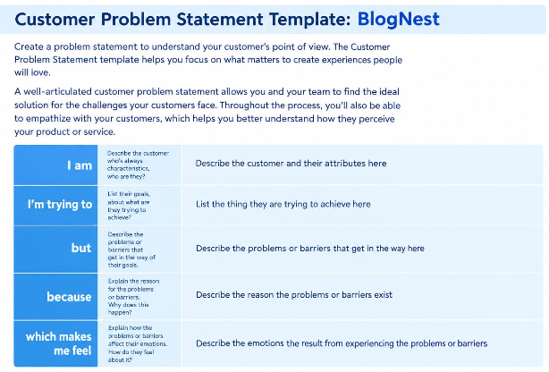
Reference: https://miro.com/templates/customer-problem-statement/

